Things To do in v2.2

Things To do in v2.1
- In experience apge the live button and certificate button must be full length width of the box they are inside. Change dates form 1st may 2025- to 31st July 2025. Also the certificate link is https://drive.google.com/file/d/1phfam616nx1uheiM0FwLC3VxW1ZNUUVp/view?usp=sharing
- For selected projects,
  - the view all project button must be bigger bolder and should have color like this  . also the button must be more bolder and more eye catching and should be visible from the start. Currently it is happening after a lot of time.
- In achiement page make these cards more bigger the buttons more visibles 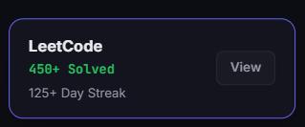

Thing to do in V2
- Each page must be like a slide. All page section must have size of the screen length, when we scroll we go to the next page. All data in it must be formatted in that way only.
- On frontend page the code must be dynamic. This thing
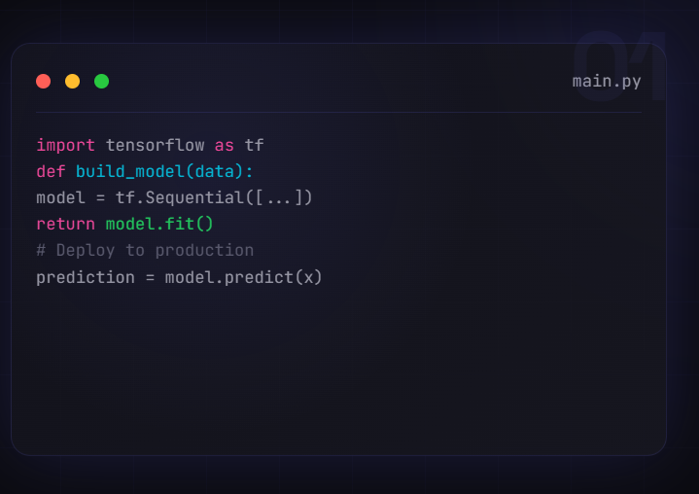
- There should be another page foe about like a different comnplte page not a slide. As a recruiter might not see it or like. It should have a completely different page. With inffor for me. Also the formatting of grid part must be done.
- In navbar we should onl have 4 thing like the main thing, abhout uss page, projects and contac us page
- In where I have worked it should have 2 buttons one to see the live webisite and for the certificate. These should have 3 state hover button. Also, content too much, only need to add part which will impress the recruiter.
- Project page, this is were the mail overhaul will happen, here in laptop we will show on 4 project here all should have ver less but impactfull content and it should also have 2 buttons one for github and one for live project view. In phgone we will have onl 2 project.
- We will another page for project whgere we will show all our projects projects for backend frontend, ml, ds and all other projects we will have a dedicate page for this. So all my project can have dtailed sections and they all can shine.
- The tookit page should be something like this 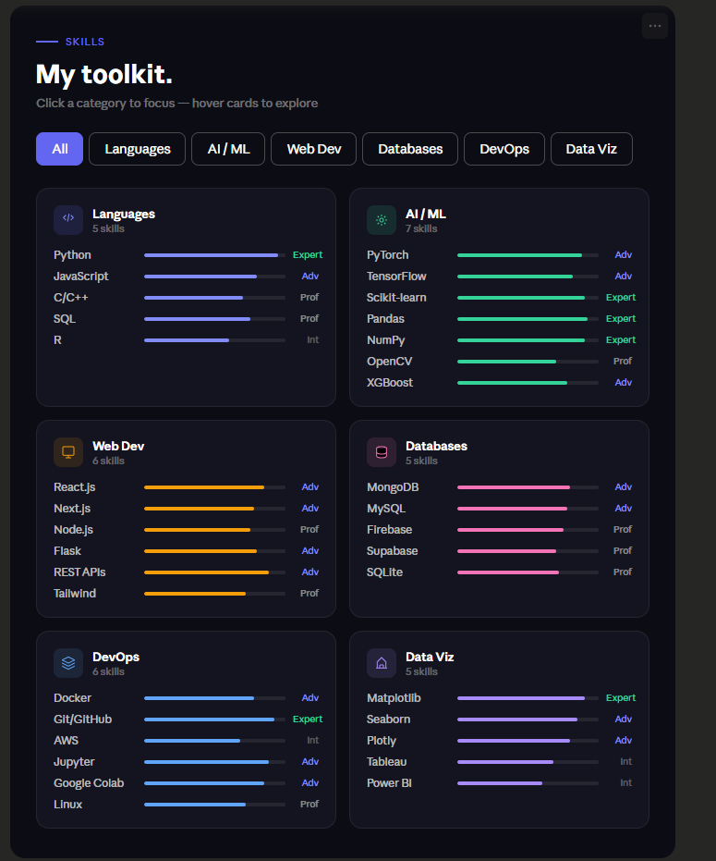
Proficiency bars instead of plain tags. A recruiter scanning in 10 seconds can now see instantly that you're an Expert in Python and Scikit-learn but Intermediate in AWS — which is honest, credible, and more useful than a flat list that implies all skills are equal.
Category filter. If a recruiter is hiring for an ML role, they click "AI / ML" and see exactly what they need. The current design makes them read all six cards every time.
Color per category. Each domain gets its own accent (green for AI/ML, indigo for languages, amber for web) so the eye can navigate spatially, not just by reading every label.
Hover lift on cards. A subtle translateY on hover makes the section feel alive and interactive rather than a static dump.
Skill count per card. Small but meaningful — "7 skills" under AI/ML tells a recruiter there's depth there before they even read it.
- For credentials better the buttons make them more promionents. the tags look too small and cluttered. Also make it more dynamic
- Contact me page like this but tailored for my approach
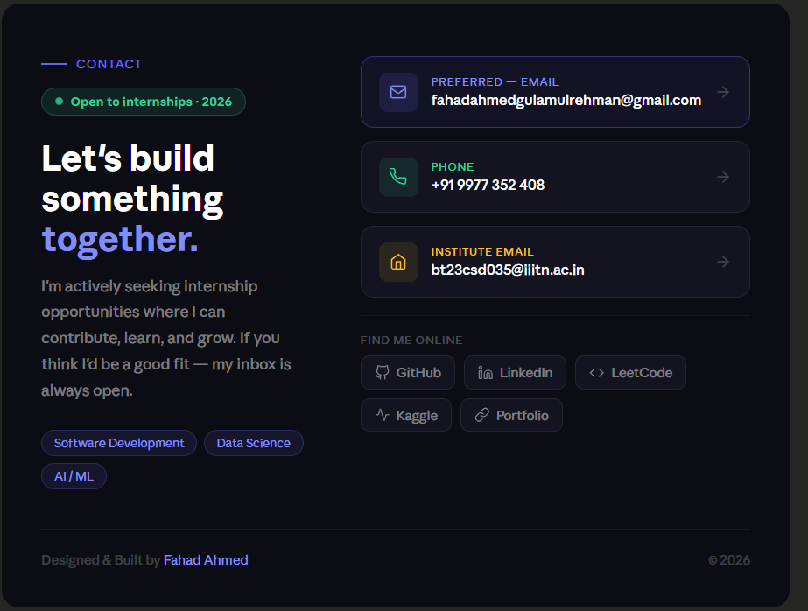

- Ask summet for the color pallet.

